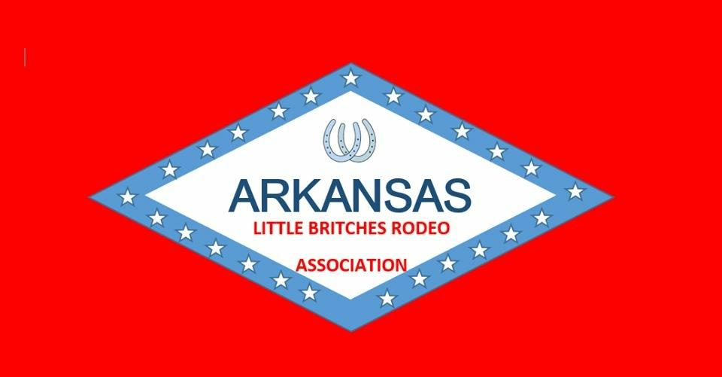
ALBRA Sponsorship Levels
$1500 Jacket Sponsor
Your company name on a sleeve of the jacket for all of the contestants. Banner hung at all rodeos. Name mentioned several times during each rodeo.

$1000 Saddle Sponsor (5 saddles)
Banner hung at all rodeos. Name mentioned several times during all the rodeos.

$350 Barrel Sponsor (5 barrels)
Name mentioned during the rodeos. Name stenciled on 1 of the 5 barrels used during competition.

$250 T-shirt Sponsor
Logo on t-shirts for all contestants. Name mentioned during the rodeos.

$200 Event Buckle Sponsor (2 buckles/event, 27 events)
A flag with sponsors name will be presented at the beginning of the rodeo. Name will be mentioned several times during that sponsored event.
*Flags/Banners/Logos are provided by Sponsor.
*Flags/Banners that are needed, please call Becky Switzer @ 501-230-7872.

$100 Single Buckle Sponsor
Name mentioned during rodeos.
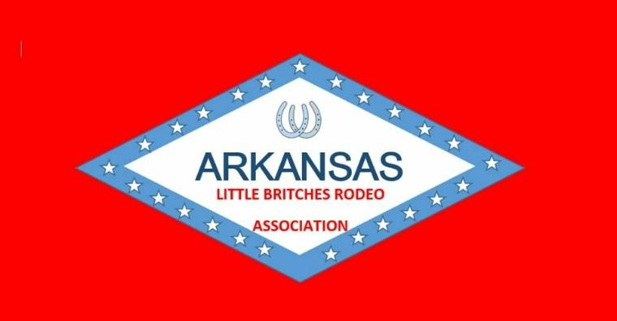

ALBRA Sponsorships
Date:_____________________________________________________________
ALBRA Member Name:_______________________________________________
Company Name:____________________________________________________
Company Representative:_____________________________________________
Company Phone #:__________________________________________________
Level of Sponsorship:(please check your choice)
_____ $1500 Jacket Sponsor

_____ $1000 Saddle Sponsor (5 saddles)
Please circle which you would like to sponsor: LW, JR Girls, JR Boys, SR Girls, SR Boys

_____ $350 Barrel Sponsor (5 barrels)

_____ $250 T-shirt Sponsor

_____ $200 Event Buckle Sponsor (2 buckles/event, 27 events)
What event would you like to sponsor?
LW flag, JR Boy flag, LW Pole, JR poles, SR pole, LW barrel, JR barrel, SR barrel, JR bull, SR bull, SR saddle bronc, SR bareback, SR tie-down, JR tie-down, JR boy breakaway, JR girl breakaway, SR girl breakaway, SR ribbon roping, JR ribbon roping, SR team roping, JR team roping, JR trail, SR trail, LW goats, SR goats, JR girl goats, JR boy goats
For office use only:
Paid cash $______
Paid check $______
Check #_______
Initials ______
_____ $100 Single Buckle Sponsor

